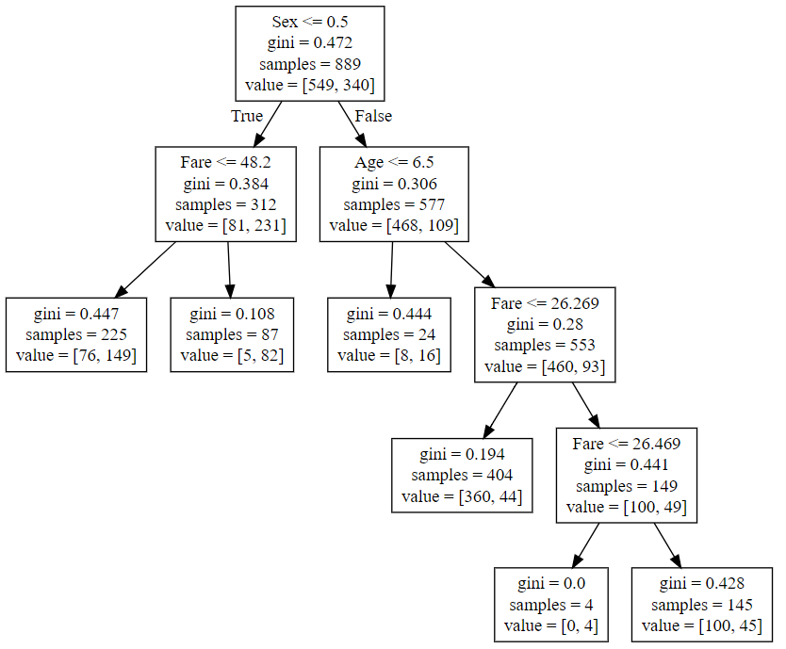

1. Out of 889 passengers 340 survived
2. 231 females and 109 males survived
3. Females who paid fair more then 48.2 has survived more . 82 survived out of 87
4. Male with age 6.5 having 100% chances of survival
5. Males with age above 7 years and fair less then 26.26 has very less chances of sruvivla